* **Name : Duwe Siriwardhana Arachchige Deshan Chinthaka**
* **Specification : Personal Finance Tracker**

**(GUI Implementation with Tkinter and OOP)**

* **Test Plan Summary**

First of all, let’s we consider what kind of taskes could be done by this program. In this program ,it will be offer to analys the personam finansial status. Users can use this program to store their expenses and see the progress of their financial status. And also provided a Graphical User Interface (GUI) by the program for enhancing the user experience.

Here are the options that offering this program to users,

1. View transaction
2. Add transaction
3. Delete transaction
4. Update transaction
5. Transaction menu
6. Display summary

When running this computer program, first of all, the user is given a command line interface by the program to select items.

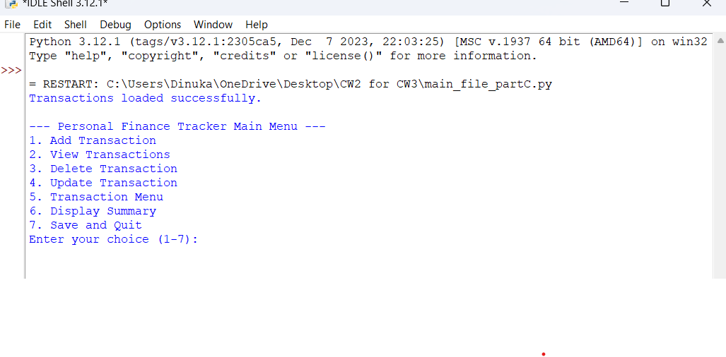

When user select an item the program navigate the CLI to function that related to selected item.

Let’s consider these operations one by one.

1. **View transactions**

This item is activated when the user enteres number 2 as the selection.

This function will display all the transactions in the ”transactions.json” file for the user to see. Here are some transactions that already entered earlier.

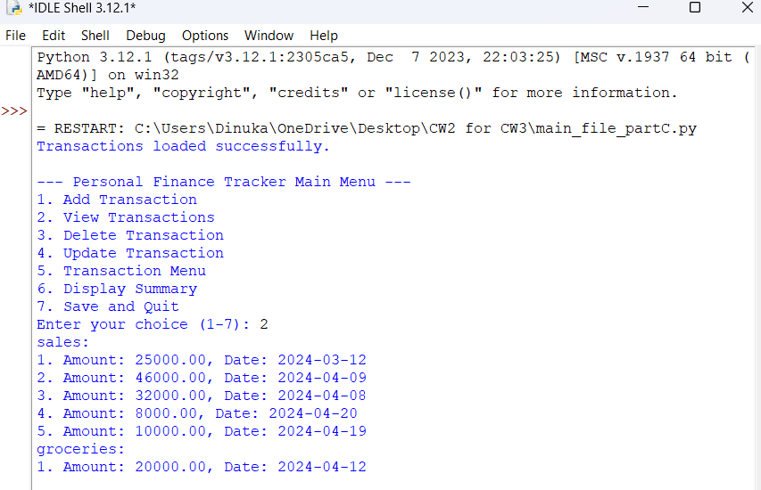

1. **Add transaction**

When the user gives number 1 for the coice then this function is triggered.

By using the “Add transaction” option, users can adding their expenses with amount and date of transaction.

Then add some transactions that categorized as “sales”. “sales” category is already exist. After entering below two of transactions ,them should added to the same “sales” category as children.

Transaction 1:- Amount: 22500 , Date: 2024-04-23

Transaction 2:- Amount: 18000 , Date: 2024-04-25

Let’s see the transaction list after adding above new transactions.

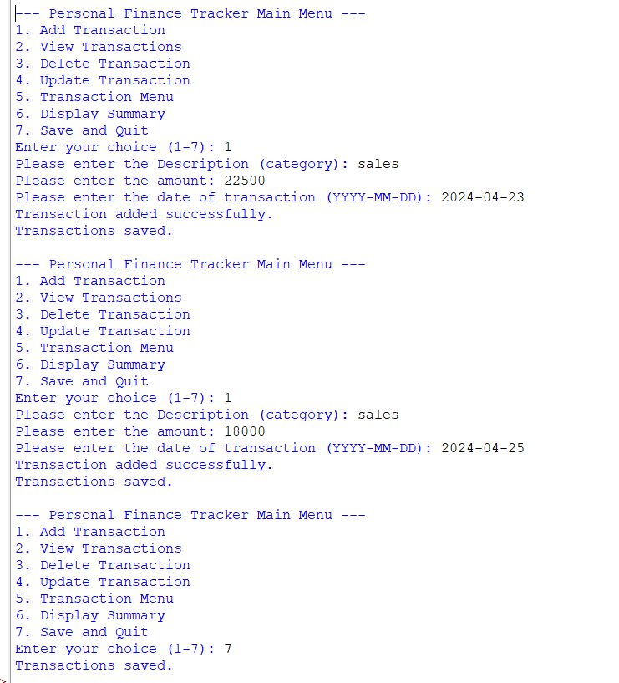

Let’s see the transaction list.

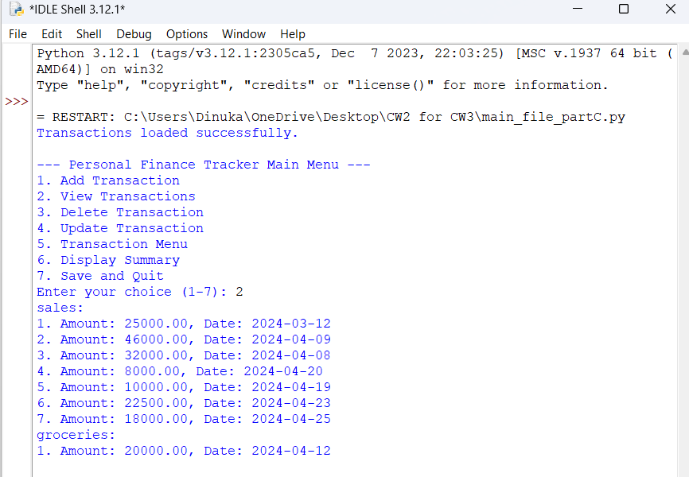

The new transactions successfully entered to the sales category as children. Therefore the expectation is became true.

Let’s add some transactions but their category is doesn’t exist in the transaction file.

Category : salaries

Transaction 1:- Amount : 85000 , Date: 2024-03-20

Transaction 2:-Amount : 90000 , Date: 2024-04-20

Category : clothes

Transaction 1:-Amount : 9300 , Date: 2024-04-19

Let’s see the transaction list after adding above new transactions.

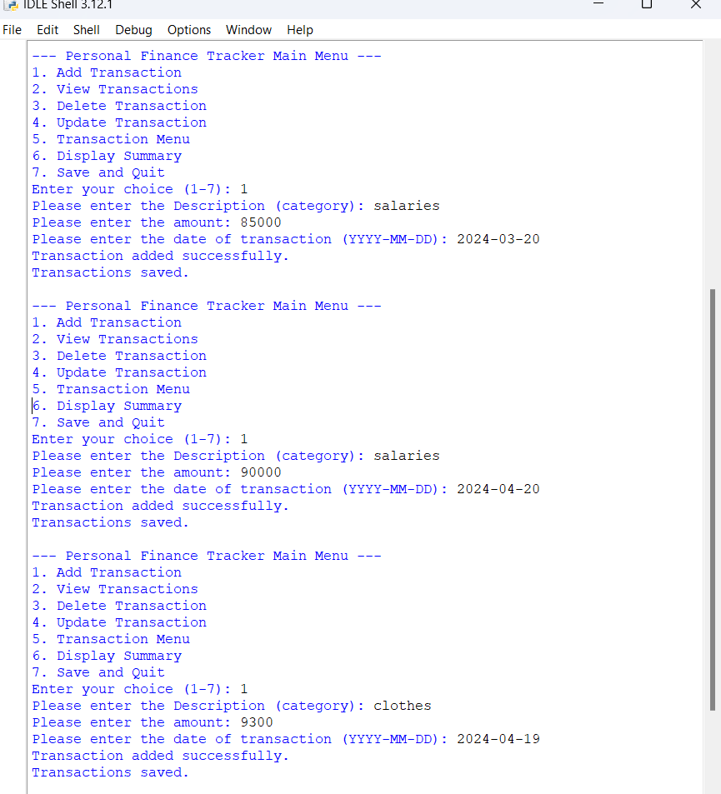

Let’s see the transaction list,

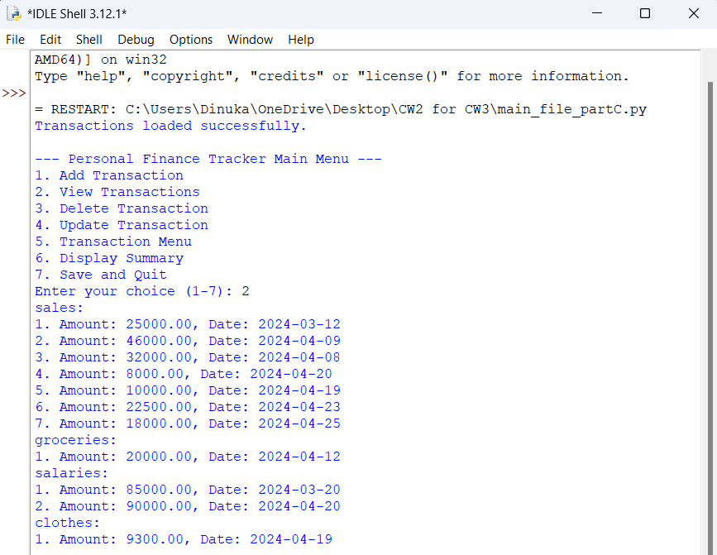

As we can see, new categorized transactions are added successfully to the transaction file.

If the user enteres an invalid value for the transaction value while entering a transaction, the computer program will stop.

Check that scenario using the invalid value entry,

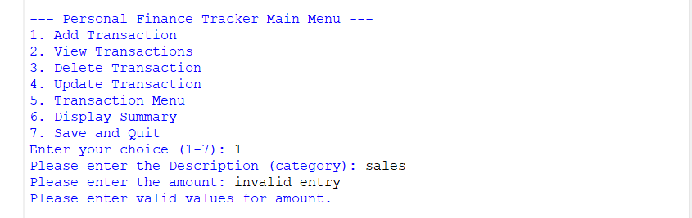

If the user enteres an invalid date entry for the transaction date while entering a transaction, the computer program will update the transaction to today’s date.

Check that scenario using the invalid date entry,

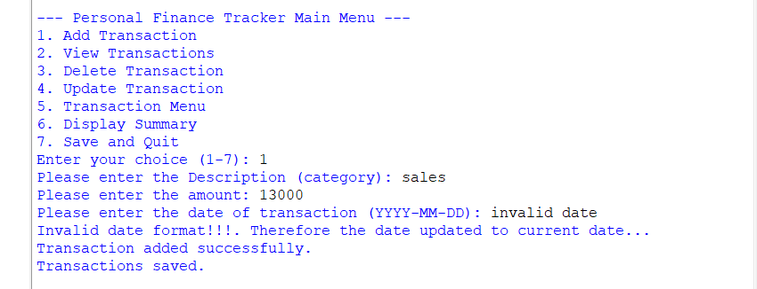

Let’s see the transactions whether new transaction is added or not.

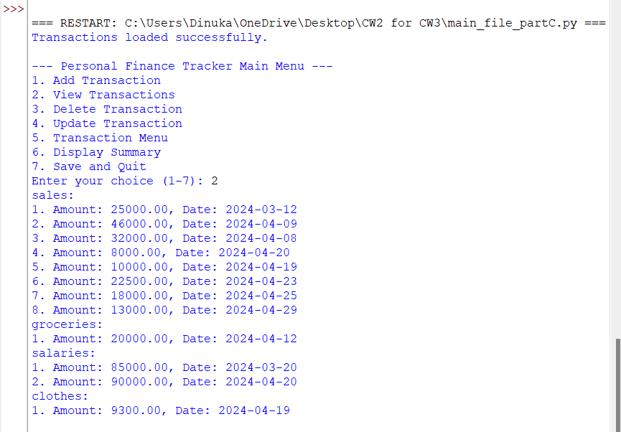

As we can see, the new transaction added successfully to today’s date.

* A conclusion that can be made from this is, that the add transaction function is working correctly.

1. **Delete Transaction**

Here the user is given an offer to delete a transaction. The requirements are the category of transaction and the number of the particular transaction. Firstly, all transactions are displayed to confirm the transaction. The way the user can confirm the transaction number.

For example let’s delete the 4th transaction in sales category,

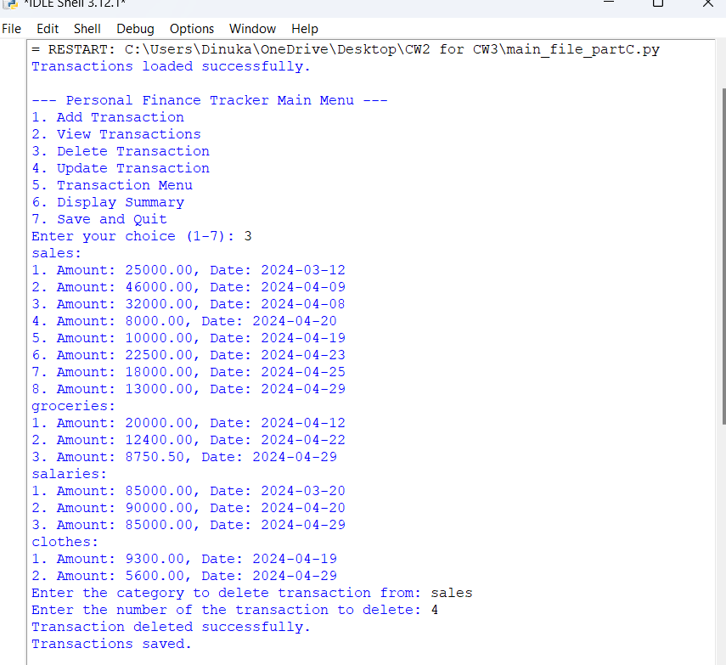

Let’s view transactions whether that particular transaction is deleted or not,

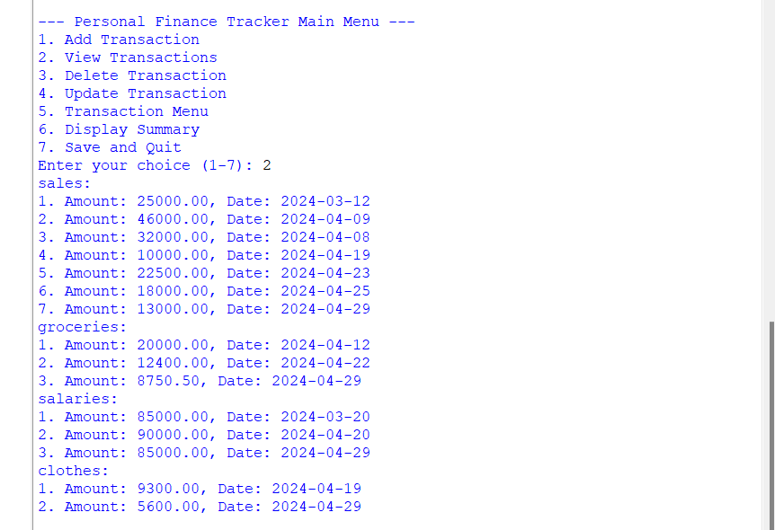

As we can see, the transaction that the number I provided has been deleted.

* A conclusion that can be made from this is, that the delete transaction function is working correctly.

1. **Update transaction**

This function gives the user an offer to change and update a particular transaction that is currently in the list. For this, the transaction category and number of transaction number are obtained from the user as required. Then he should enter the new value and the new date to update it.

For example, let’s update a transaction in the “sales” category.

Cetegory: sales

Transaction number 1 change to 🡪

Amount : 23500 , Date : 2024-04-15

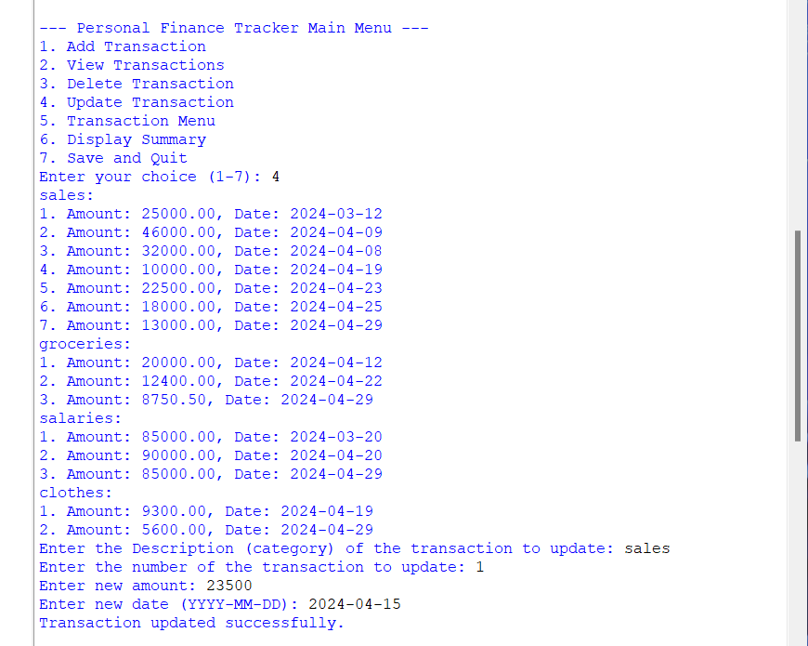

Let’s view transactions whether that particular transaction is updated or not,

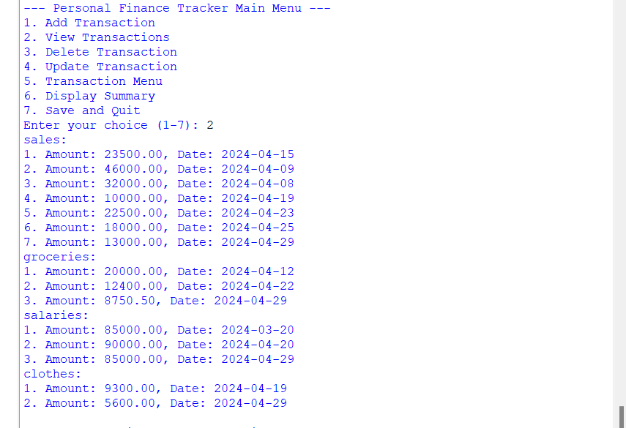

As we can see, the transaction that the number I provided has been replaced with given new entries.

If the user enteres an invalid value for the transaction value while updating a transaction, the computer program will stop.

Check that scenario using the invalid value entry,

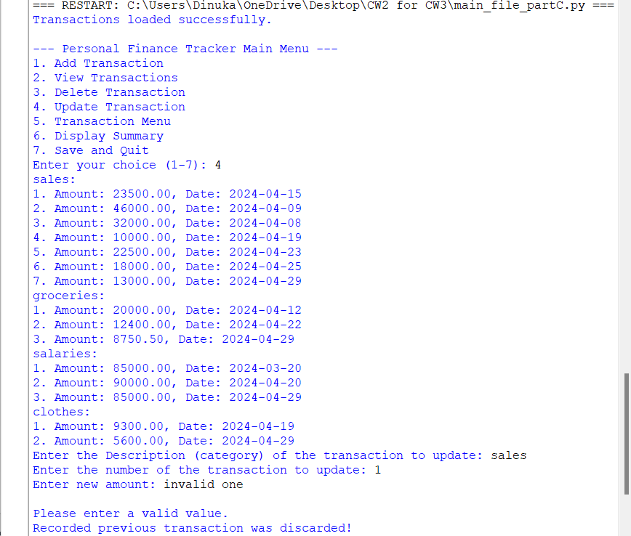

If the user enteres an invalid date entry for the transaction date while updating a transaction, the computer program will update the transaction to today’s date.

Check that scenario using the invalid date entry,

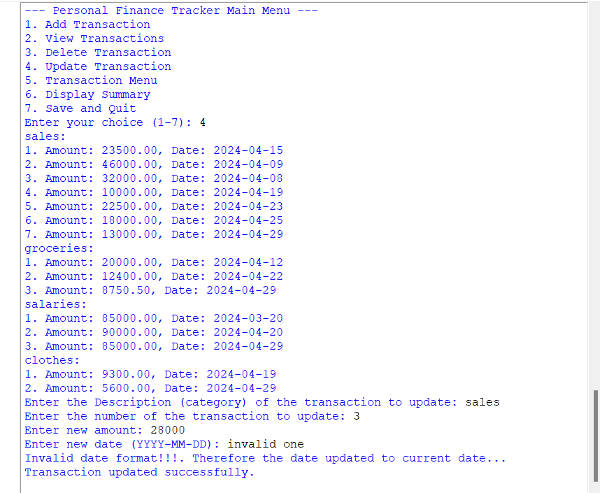

Let’s see whether that articular transaction is updated or not,

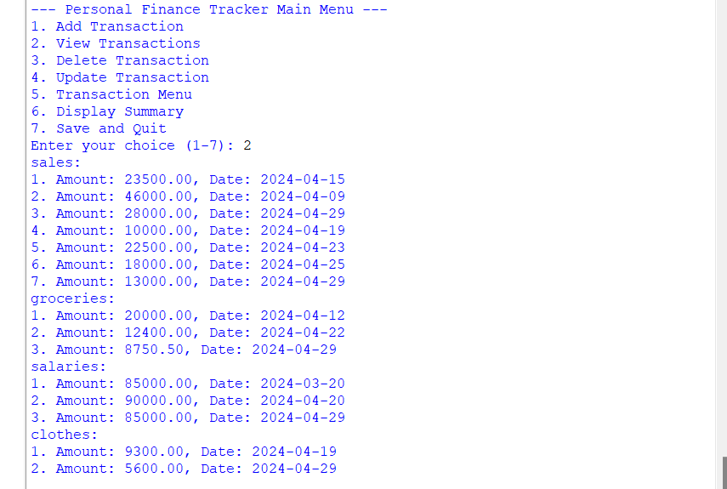

As we can see the transaction is updated succefully and add to the transaction file.

* A conclusion that can be made from this is, that the update transaction function is working correctly.

1. **Transaction menu**

This is the main thing that provided in this coursework. The computer program implemented with using GUI by using “Tkinter” .

The task of this is to show the user all the current transactions has been done so far through the Graphical User Interface (GUI). Also, a search button has been included in this interface , so that user can find a particular transaction he want.

Also, provide a sorting option to sort transaction related to Treeview headings.

Let’s run this function to get an idea.

c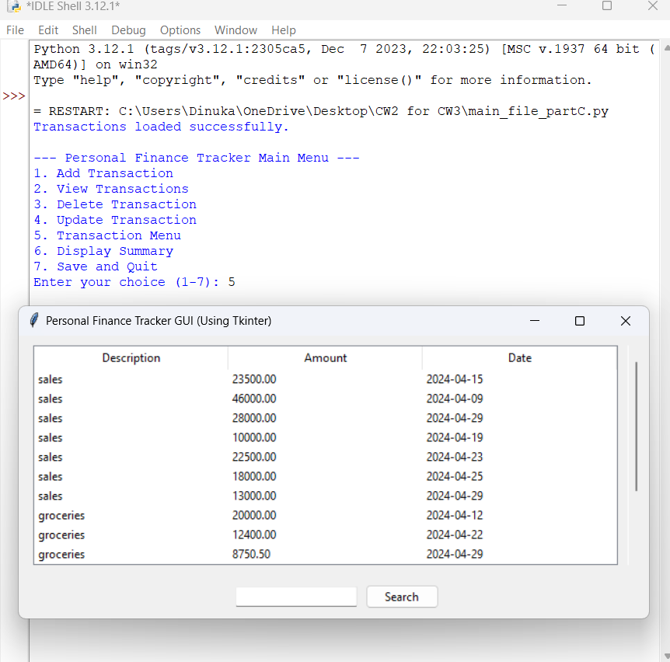

All the transactions currently done by the user, are shown by this interface. Transactions are displayed here in the order related to the dictionary file.

**Search option:-**

* + Search by Description
  + Search by transaction Date

In this option, user can search for a particular transaction by entering the transaction description or date of the transaction.

Search by description

When the user enters the name of the transaction that he wants to search for in search bar, all the transactions with that name will be displayed In this interface.

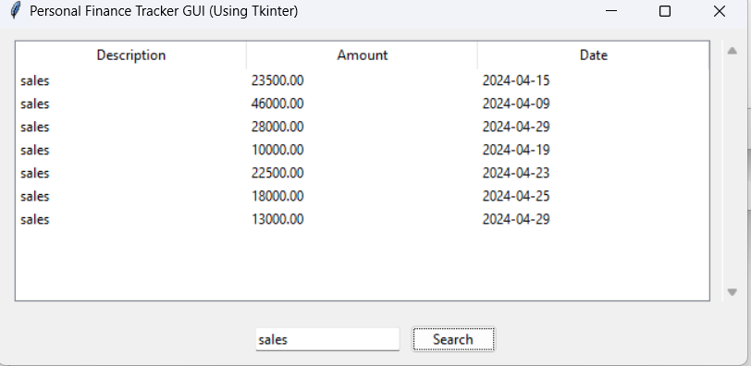

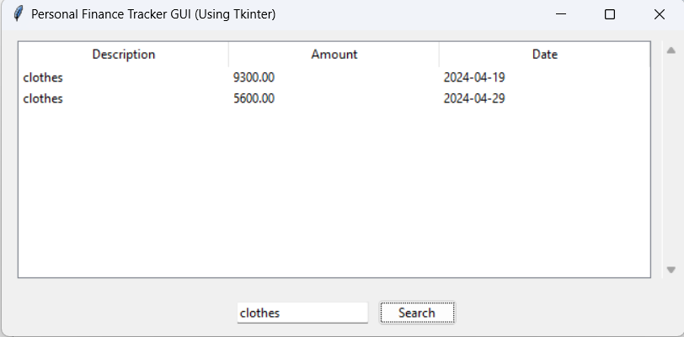

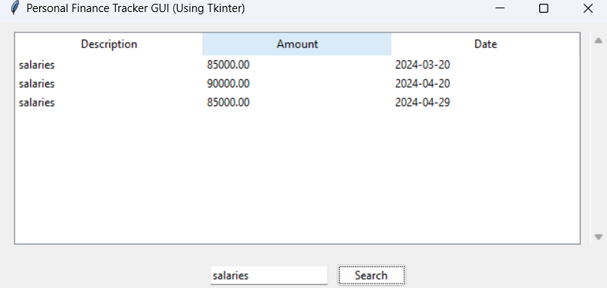

If the category that entered by user is doesn’t exist in the JSON file, then all transactions will display in the interface

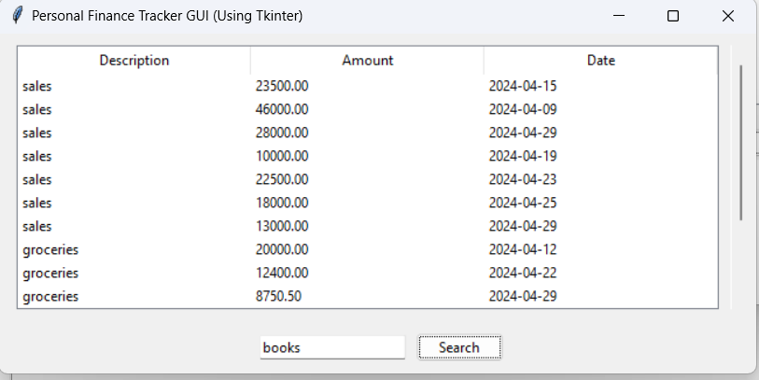

**Sorting option**

If the user touches the date column of transaction table, the dates will be arranged in ascending order and displayed in the GUI interface. Also, if the user touches the value column, the values will be arranged in ascending order.

Apply ascending order to “Date” column

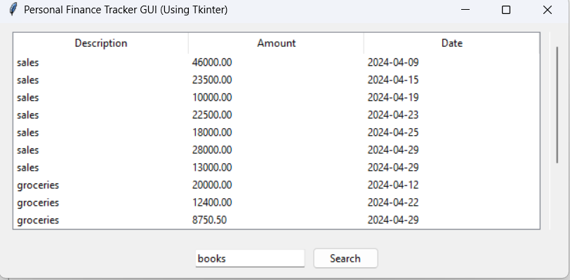

Apply ascending order to “Amount” column,

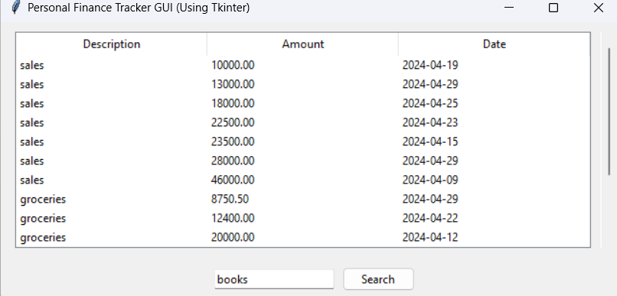

* A conclusion that can be made from this is, that the “transaction menu” function is working correctly.

1. **Display summary**

In this option, the program provides a summary of all transactions In category wise.

Total amounts of each category will display .

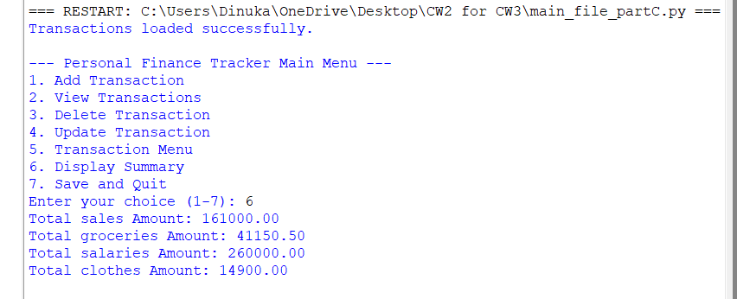

* In conclusion that can be made from this is, that the “display summary” function is working correctly.
* Thus it is clear that this computer program runs every option without giving any errors.